PHASE 4 DEVELOPMENT PART-2
NOISE POLLUTION MONITORING SYSTEM

TECHNOLOGY USED :
Noise Sensors:
These are the primary components for capturing sound. Common typesinclude microphones or sound level meters, which convert sound waves into electrical signals.
BUZZER:
When noise levels exceed predefined thresholds, the system can trigger alerts.
IOT DEVICE :
NodeMCU are used to interface with sensors, process data, and communicate with the IoT platform.

CODING:
Implementation in IoT devices:

#include <ESP8266WiFi.h>
#include <AdafruitIO.h>

// Wi-Fi credentials
#define WIFI_SSID "YourSSID"
#define WIFI_PASS "YourPassword"

// Adafruit IO credentials
#define IO_USERNAME "YourAIOUsername"
#define IO_KEY "YourAIOKey"

// Sound sensor analog pin
const int soundSensorPin = A0;

// Adafruit IO client
AdafruitIO_Client io(IO_USERNAME, IO_KEY);

void setup() {
Serial.begin(115200);

// Connect to Wi-Fi
WiFi.begin(WIFI_SSID, WIFI_PASS);
while (WiFi.status() != WL_CONNECTED) {
delay(1000);
Serial.println("Connecting to WiFi...");
}
Serial.println("Connected to WiFi");

// Connect to Adafruit IO
io.connect();

// Set up a feed for noise level
AdafruitIO_Feed *noiseLevel = io.feed("noise-level");

// Your setup code for sound sensor, calibration, and other configurations
}

void loop() {
// Read noise level from the sound sensor
int noiseLevelValue = analogRead(soundSensorPin);

// Send the noise level data to Adafruit IO
AdafruitIO_Feed *noiseLevel = io.feed("noise-level");
noiseLevel->save(noiseLevelValue);

Serial.print("Noise Level (dB): ");
Serial.println(noiseLevelValue);

delay(60000); // Send data every 1 minute
}
CIRCUIT DIAGRAM :

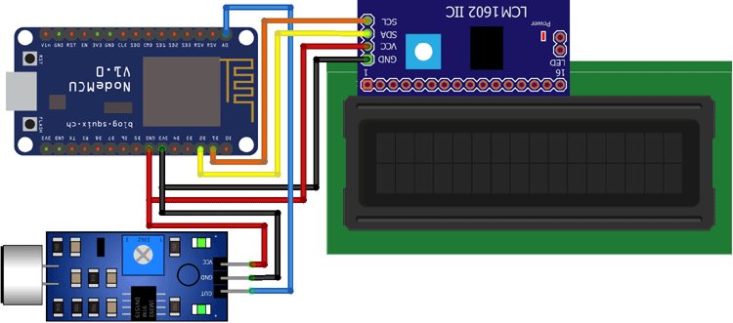

CONCLUSION :
In summary, IoT-based noise pollution monitoring systems provide a versatile and effective means to monitor, manage, and mitigate noise pollution in various settings. These systems contribute to improved quality of life, public health, and urban planning, making them a valuable tool for addressing the challenges associated with noise pollution in our modern world.

